Earley Town Council
Annual Meeting - 17th May 2023
Agenda Item 13
CIVILITY & RESPECT PLEDGE
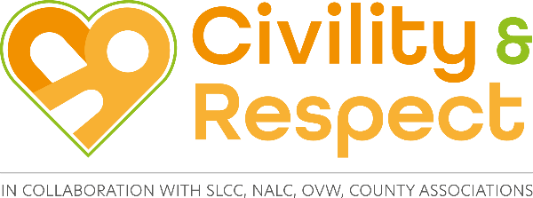

Definition of Civility and Respect

Civility means politeness and courtesy in behaviour, speech, and in the written word.

Examples of ways in which you can show respect are by listening and paying attention to others, having consideration for other people’s feelings, following protocols and rules, showing appreciation and thanks, and being kind.

The National Association of Local Councils (NALC), the Society of Local Council Clerks (SLCC), and One Voice Wales (OVW), believe now is the time to put civility and respect at the top of the agenda and start a culture change for the local council sector.

By our council signing up to the civility and respect pledge we are demonstrating that our council is committed to treating councillors, clerks, employees, members of the public, representatives of partner organisations, and volunteers, with civility and respect in their role.

Further information on virtual workshops and toolkits is available at www.slcc.co.uk/news-publications/civilty-respect-project and www.nalc.gov.uk/our-work/civility-and-respect-project

Signing up is a simple process, which requires councils to register and agree to the following statements:

Statement | Tick to agree
Our council has agreed that it will treat all councillors, clerk and all employees, members of the public, representatives of partner organisations, and volunteers, with civility and respect in their role.

Our council has put in place a training programme for councillors and staff

Our council has signed up to Code of Conduct for councillors

Our council has good governance arrangements in place including, staff contracts, and a dignity at work policy.

Our council will commit to seeking professional help in the early stages should civility and respect issues arise.

Our council will commit to calling out bullying and harassment when if and when it happens.

Our council will continue to learn from best practice in the sector and aspire to being a role model/champion council e.g., via the Local Council Award Scheme

Our council supports the continued lobbying for the change in legislation to support the Civility and Respect Pledge, including sanctions for elected members where appropriate.

To date, 1,176 local councils have signed up to the Civility & Respect pledge.

Jo Friend
Town Clerk
May 2023

