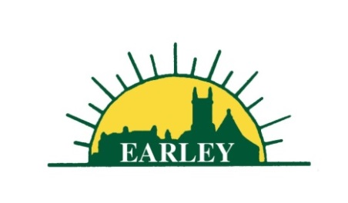
EARLEY TOWN COUNCIL
Town Clerk
Application Pack
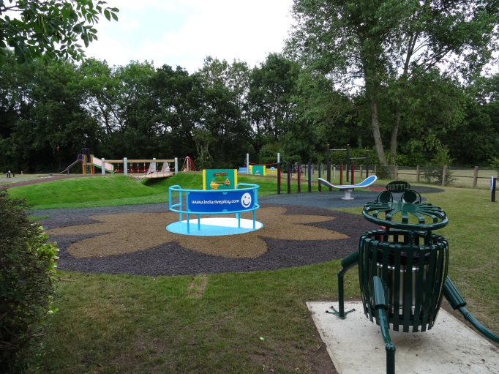
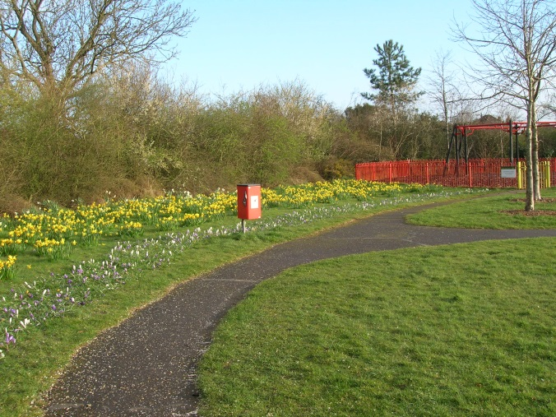

Recruitment of Town Clerk
& Responsible Financial Officer

Salary Scale LC4 (SCP 56 – 60) £53,131 - £59,901 per annum
(depending upon experience and qualifications and with the possibility of progression beyond this point if CiLCA qualification is achieved)

Earley is a small town in Berkshire, alongside the M4 and the River Thames, adjacent to Reading and part of Wokingham Borough Council. It serves a population of some 33,000 and provides a range of attractive services: parks, a nature reserve, ancient and community woodlands, allotments, several sports and community facilities. Earley has a long and interesting history dating from Roman times. The Town Council was established in 1974.

Following the retirement of the current Town Clerk, the Council is seeking to appoint a forward thinking and proactive Town Clerk to take responsibility for all aspects of the managerial, administrative and financial operation of the Council. The Town Clerk will be responsible for the management of the Council’s finances, and is designated as the ‘Responsible Finance Officer’.

The Town Council strives to provide the community of Earley with good quality services and to maintain these services to a high standard. The Town Clerk will ensure the delivery of these services. The Town Clerk will be accountable to Earley Town Council as a corporate body.

The Town Clerk will have full responsibility for ensuring that the instructions of the Council are carried out. The Clerk is expected to advise the Council on, and assist in the formation of, overall policies to be followed in respect of its activities and, in particular, to produce all information required for making effective decisions. The Town Clerk is accountable to the Council for the effective management of all its resources and will report to them as and when required.

Applicants must be able to demonstrate that they have extensive managerial and financial experience. The Council has a budget of £1.2 million and is subject to the statutory accounting procedures. Candidates should have a more than sound knowledge of local government law and procedures, hold a relevant professional qualification and show that they have or can obtain the Certificate in Local Council Administration.

The closing date for the receipt of applications is Tuesday 29th May 2018 at 12 noon.
Interviews are planned for 13th June 2018 and the start date is expected to be between
1st August and mid October 2018 (dependent upon notice period of successful candidate).

The application pack is on our website at www.earley-tc.gov.uk. Alternatively, to request an application pack or for an informal discussion about the post contact Philip Truppin at Earley Town Council, Council Offices, Radstock Road, Earley, Reading RG6 5UL, telephone 0118 9868995 or email administration@earley-tc.gov.uk.

Please read the information in this document before you complete your application form.

You will need to make clear in your application form:

- Why you are interested in the position
- What relevant skills and experience you have (refer to the Job Description and Person Specification)

Please complete the application form in full as shortlisting will be based on the information provided in the form. Only completed application forms will be accepted, please do not send CVs. References will be taken up for all shortlisted candidates

Please return forms either
- via email marked Private & Confidential to administration@earley-tc.gov.uk
- or by post in a sealed envelope marked Private & Confidential to Philip Truppin at Earley Town Council, Council Offices, Radstock Road, Earley, Reading RG6 5UL

Earley Town Council is committed to Equality of Opportunity and actively welcomes applications from all sections of the community.

