COMMUNITY FLOOD WARDEN SCHEME IN EARLEY
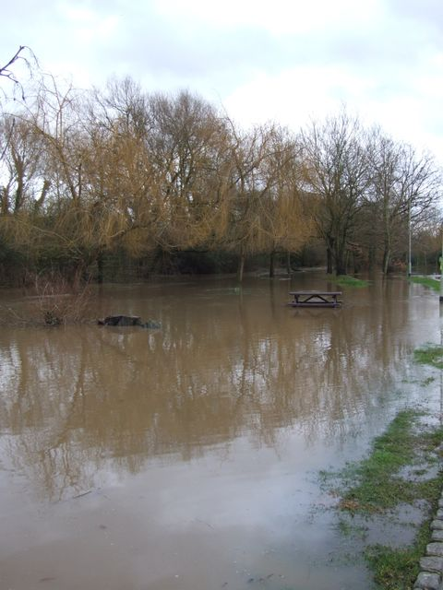
Community Flood Warden schemes are completely voluntary, and can consist of a single person or several people acting as volunteers to help raise awareness of any flood risks in their community, help pass on flood warnings when they are issued, help prepare for flooding and to help vulnerable people both during and after flooding has occurred. A Community Flood Warden may also be part of another group such as a Neighbourhood Watch or Parish Council.
Community Flood Wardens are an important part of the local community, but can also play a key role in assisting the Environment Agency, Thames Water, and Wokingham Borough Council with local information on flood conditions. For example; before or during a potential flooding event the Community Flood Wardens may be contacted to give an account of flood conditions. For example; before or during a potential flooding event the Community Flood Wardens may be contacted to give an account of ground conditions, water levels, weather, etc, to help the Emergency Planning team and Environment Agency activate relevant plans and to coordinate an appropriate response across the country.
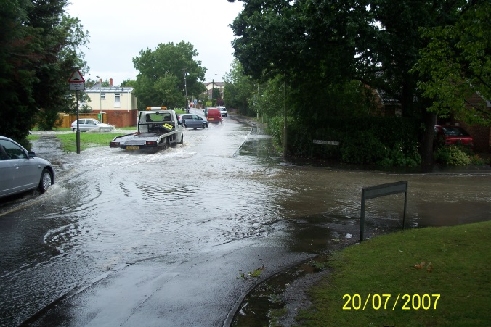
Community Flood Wardens may notice or have been given information about a blocked watercourse, culvert, and drain or burst pipe. The Community Flood Warden should then report this to the relevant agency so that the necessary remedial action is carried out. By doing this, watercourses will be kept flowing unobstructed thus reducing the risk of local flooding.
Locally appointed Community Flood Wardens are important because:
- Local people will know the Community Flood Warden personally, leading to mutual trust and understanding.
- Local people are more likely to accept warnings and advice which are reinforced by a familiar local person.
- A local Community Warden would be familiar with those people and properties at risk. They could distribute leaflets on flood warning and emergency response arrangements to properties at risk of flooding and ensure people receive and understand them.
- A local Community Flood Warden would be able to provide the Environment Agency and Wokingham Borough Council with local information during a flood event and confirm conditions on the ground. An important two way information link would be established

Community Flood Wardens can:
- Encourage communities to help themselves with training and support from the Environment Agency, Wokingham Borough Council and the Emergency Services.
- Develop good local communication links with other local groups for passing out information and receiving feedback.
- Help build partnerships which would bring improvements in flood preparedness and response such as with Neighbourhood Watch and Parish Councils.
What would a Community Flood Warden do?
The role of the Community Flood Warden is primarily one of communication, and there are many ways in which a Community Flood Warden can help their local community in times of flood. These include:
- Assist with the creation and maintenance of the Community Flood Plan with the Environment Agency and Wokingham Borough Council.
- Monitor the condition of local drains, culverts, brooks and other watercourses and report any defects or blockages to the appropriate agency.
- Distributing flood related information to the public.
- Encouraging individuals to sign up to the Environment Agency free flood warning service, Floodline Warnings Direct where available.
- Making arrangements to reinforce flood warnings when they are issued.
- Visit people at risk to ensure that warnings have been received.
- Call for assistance on behalf of people who are struggling to carry out essential actions to safeguard themselves or their property.
- Have local knowledge and information on the latest flood situation (the Environment Agency and Wokingham Borough Council will help with this).
- Liaise with the Environment Agency, Wokingham Borough Council and emergency services on local conditions and needs on the ground.
- Note and report local flood event details.
- If possible set up local patrols to monitor the situation.
For more information please contact the flooding team at Wokingham Borough Council at flooding@wokingham.gov.uk

